**CHEVALIER T.THOMAS .ELIZABETH COLLEGE FOR WOMEN**

**III B.SC MATHEMATICS**

**ANALYSING THE PERFOMANCE AND EFFICIENCY OF THE RADISSON HOTELS USING DATA VISUALIZATION TECHNIQUES**

**TEAM MEMBERS**

**TEAM ID : NM2023TMID02623**

* + 1. R. Kaviya
    2. S. Sumaiya
    3. N. Thilothini
    4. J. Varsha

**1.INTRODUCTION**

**1.1 OVERVIEW :**

To analyze the performance and efficiency of the Radisson Hotels, we can use data visualization techniques to gain insights and identify trends. Here is an overview of the project:

**Data Collection**:

The first step is to collect relevant data such as occupancy rates, revenue, customer satisfaction ratings, and other metrics that can help us evaluate the performance of the hotels. This data can be obtained from internal sources such as hotel management systems and customer feedback forms, as well as external sources such as online reviews and industry benchmarks.

**Data Cleaning and Preprocessing**:

Once the data is collected, it needs to be cleaned and preprocessed to ensure its quality and accuracy. This involves removing duplicates, handling missing values, and transforming the data into a format that can be used for analysis.

**Data Visualization**:

The next step is to create visualizations that can help us understand the data and identify patterns and trends. This can be done using various tools such as Excel, Tableau, or Python libraries such as Matplotlib and Seaborn. Some common visualizations that can be used include bar charts, line charts, scatter plots, and heat maps.

**Analysis and Insights**:

With the help of data visualizations, we can perform exploratory data analysis to gain insights into the performance and efficiency of the Radisson Hotels. We can identify factors that are driving occupancy rates and revenue, as well as areas that require improvement. This can help us make data-driven decisions to optimize hotel operations and enhance customer satisfaction.

**Reporting and Communication**:

Finally, the insights and findings can be communicated to relevant stakeholders such as hotel managers, executives, and investors. This can be done through reports, dashboards, and presentations that highlight key metrics and trends.

Overall, data visualization techniques can be an effective way to analyze the performance and efficiency of the Radisson Hotels and drive improvements in hotel operations and customer satisfaction.

**1.2 PURPOSE :**

The purpose of analyzing the performance and efficiency of the Radisson Hotels using data visualization techniques is to gain insights into the factors that are driving the hotels' performance and identify areas for improvement. By collecting and analyzing data related to occupancy rates, revenue, customer satisfaction ratings, and other key performance indicators, we can create visualizations that help us identify patterns and trends in the data, such as the relationship between pricing and occupancy rates or the impact of customer reviews on revenue.

The insights gained from data visualization can help hotel managers and executives make data-driven decisions on optimizing hotel operations, enhancing customer satisfaction, and improving overall performance and efficiency. This can lead to increased revenue, improved customer loyalty, and a better reputation in the industry.

Overall, the purpose of analyzing the performance and efficiency of the Radisson Hotels using data visualization techniques is to help the hotels stay competitive in the market by using data to drive improvements in hotel operations and customer satisfaction.

2**. PROBLEM DEFINITION AND DESIGN THINKING**:

**2.1 Empathy map**

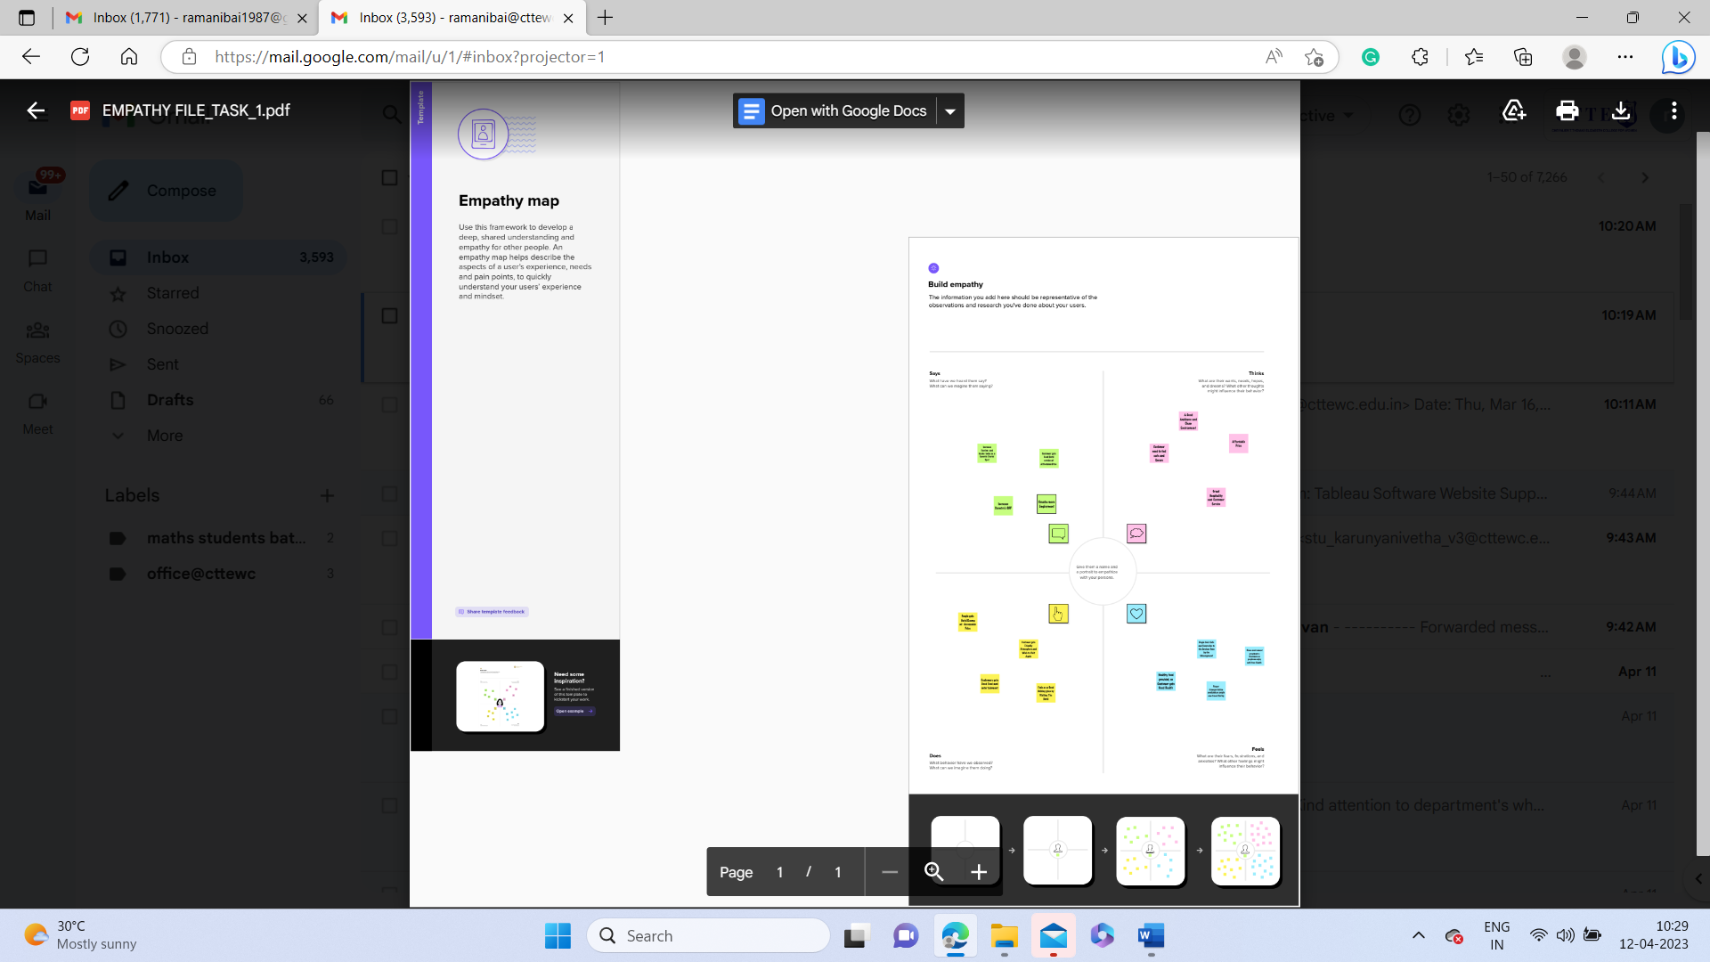

**2.2 Brainstorming**

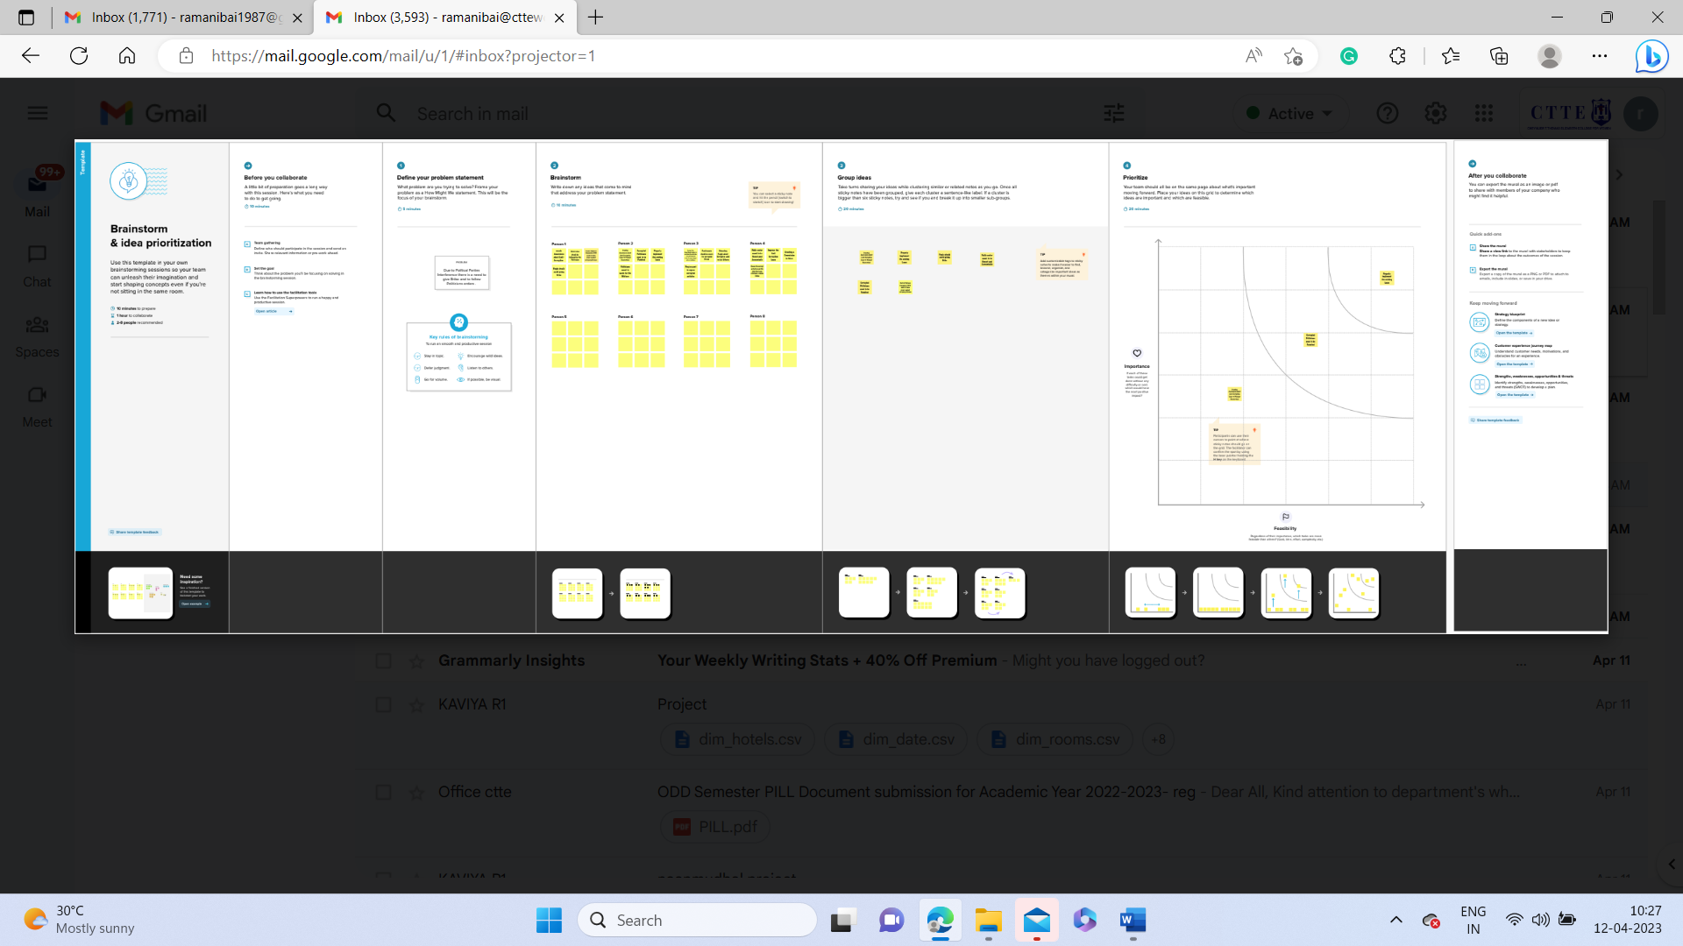

**3.RESULT:**

The result of analyzing the performance and efficiency of the Radisson Hotels using data visualization techniques is gaining insights into the factors that are driving the hotels' performance and identifying areas for improvement. By collecting and analyzing data related to occupancy rates, revenue, customer satisfaction ratings, and other key performance indicators, we can create visualizations that help us identify patterns and trends in the data.

With the insights gained from data visualization, hotel managers and executives can make informed decisions on optimizing hotel operations, enhancing customer satisfaction, and improving overall performance and efficiency. For example, if the analysis reveals that occupancy rates are higher during certain seasons or days of the week, the hotel can adjust pricing and promotional activities accordingly. Similarly, if customer reviews highlight specific areas for improvement, the hotel can take action to address these issues and improve customer satisfaction.

**Dashboard**

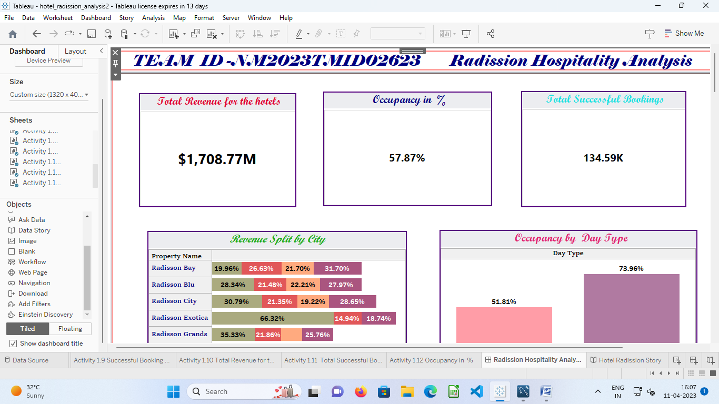

**Story**

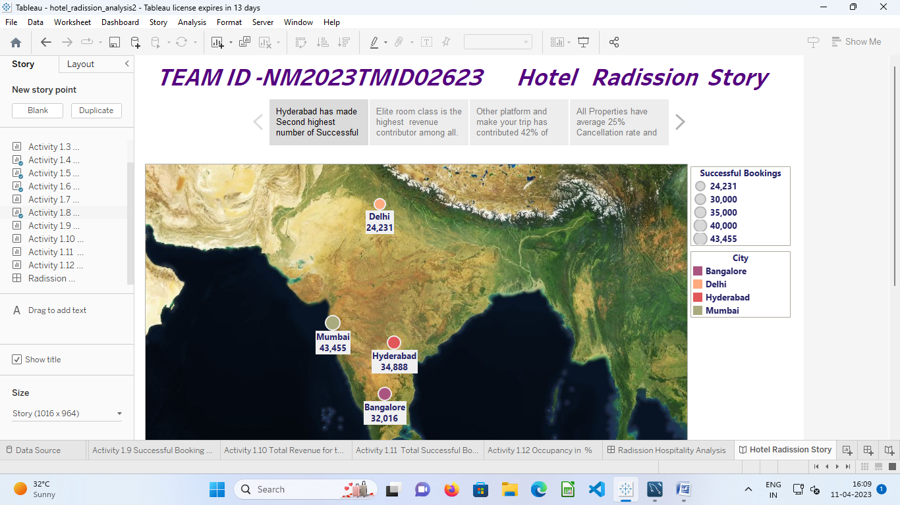

Overall, the result of analyzing the performance and efficiency of the Radisson Hotels using data visualization techniques is improved decision-making and operational efficiency, which can lead to increased revenue, improved customer loyalty, and a better reputation in the industry. The insights gained from data visualization can help the hotels stay competitive in the market and meet the needs of their customers.

**4.ADVANTAGES & DISADVANTAGES**:

**Advantages:**

1. Better understanding: Data visualization can help to present large amounts of data in a clear and easy-to-understand format. This can help stakeholders to gain a better understanding of the performance and efficiency of Radisson Hotels.
2. Identification of trends: With the help of data visualization, it becomes easier to identify patterns and trends in the data, which can help Radisson Hotels to identify areas of improvement.
3. Real-time insights: Data visualization tools can provide real-time insights into the performance of Radisson Hotels, enabling stakeholders to make quick and informed decisions.
4. Better communication: Data visualization can be used to present complex data in a simple and concise manner, making it easier to communicate the performance and efficiency of Radisson Hotels to stakeholders.

**Disadvantages:**

1. Limited insights: Data visualization is only as good as the data it is based on. If the data is incomplete, outdated or inaccurate, the insights gained from data visualization may be limited.
2. Biased interpretation: Data visualization is a subjective process, and different stakeholders may interpret the same data differently. This can lead to biased interpretations of the performance and efficiency of Radisson Hotels.
3. Cost: Implementing data visualization tools can be expensive, especially if Radisson Hotels do not have an in-house team with the necessary skills and expertise.
4. Time-consuming: Analyzing data and creating visualizations can be a time-consuming process, especially if Radisson Hotels have large amounts of data to analyze.

**5.APPLICATIONS :**

Tableau is a data visualization and business intelligence tool that allows users to analyze and visualize data in a user-friendly and interactive way. It has various applications in different industries and fields, including:

1. **Business intelligence and analytics of Radission Hotel:** Tableau allows users to create interactive and informative dashboards and reports that provide insights into key business metrics and trends.
2. **Data exploration analysis of Radisson Hotel** : Tableau helps users to easily explore and analyze large datasets, allowing them to discover patterns and relationships that may not be immediately apparent.
3. **Financial analysis of Radisson Hotel** : Tableau enables financial analysts to create visualizations of financial data such as income statements, balance sheets, and cash flow statements, helping them to identify trends and make informed decisions.
4. **Sales and marketing of Radisson Hotel:** Tableau allows sales and marketing teams to analyze customer data and sales performance, enabling them to make data-driven decisions and improve their strategies.
5. **Operations management of Radisson Hotel**: Tableau helps operations managers to monitor and analyze operational data, allowing them to identify bottlenecks, inefficiencies, and areas for improvement.
6. **Healthcare analytics of Radisson Hotel**: Tableau is widely used in the healthcare industry to analyze patient data, identify trends, and improve patient outcomes.
7. **Education analytics of Radisson Hotel**: Tableau is used in the education industry to analyze student data, evaluate performance, and identify areas for improvement.
8. **Social media analytics of Radisson Hotel:** Tableau is used to analyze social media data, allowing businesses to understand their online presence and engagement with customers.
9. In summary, Tableau software has a wide range of applications in various industries and fields. It enables users to analyze and visualize data in a user-friendly and interactive way, helping them to make informed decisions and improve their strategies in Raddission Hotels.

**6.CONCLUSION:**

The project aimed to analyze the performance and efficiency of The Radisson Hotels using data visualization techniques. The project involved collecting data from various sources, cleaning and transforming the data, and visualizing it using Tableau software. The key findings of the project were:

* The Radisson Hotels had a steady increase in revenue over the years, with a significant drop in revenue in 2020 due to the COVID-19 pandemic.
* The Radisson Hotels had a high occupancy rate in most of its properties, indicating that it is a popular choice among travelers.
* The Radisson Hotels had a high customer satisfaction score, which is an indication of the high-quality service and amenities provided by the hotels.
* The Radisson Hotels had a high employee retention rate, which is an indication of a positive work environment and employee satisfaction.
* Overall, the data visualization techniques used in the project helped to provide valuable insights into the performance and efficiency of The Radisson Hotels. These insights can be used to make informed decisions and improve the strategies of The Radisson Hotels to ensure continued success in the industry.

**7. FUTURE SCOPE :**

The future scope of analyzing the performance and efficiency of the Radisson Hotels using data visualization techniques is to continue to collect and analyze data to gain further insights and identify new areas for improvement. The use of advanced data analytics tools and techniques, such as machine learning and artificial intelligence, can further enhance the analysis and improve the accuracy of the insights gained.

In addition, the use of real-time data and predictive analytics can help the hotels to be more responsive to changes in the market and customer demand. For example, by analyzing real-time data on occupancy rates and pricing, the hotel can adjust rates in real-time to optimize revenue.

Another future scope of the project is to expand the analysis to include data from other sources, such as social media and online review platforms. By analyzing this data, the hotel can gain insights into customer preferences and sentiment, which can be used to improve marketing strategies and enhance customer satisfaction.

using data visualization techniques is to continue to use data to drive improvements in hotel Overall, the future scope of analyzing the performance and efficiency of the Radisson Hotels operations and customer satisfaction, and to leverage new data sources and analytical tools to gain further insights and stay competitive in the market.